**The AstroSage Dataset include(Schemas) –**

* **_id:** Unique identifier for each record.
* **user:** User ID associated with the record.
* **chatStatus:** Status of the chat (e.g., incomplete, failed, completed).
* **guru:** Unique identifier for the guru.
* **guruName:** Name of the guru.
* **gid:** Guru ID.
* **uid:** User ID.
* **consultation Type:** Type of consultation (e.g., Chat, Call).
* **website:** Source of the consultation (e.g., gurucool).
* **Refund Status:** Indicates if the session is refundable or not (e.g., no-refund).
* **is WhiteList User:** Boolean indicating if the user is whitelisted.
* **chat Seconds:** Duration of the chat in seconds.
* **queue:** Boolean indicating if the session was queued.
* **FreeCall:** Boolean indicating if the call was free.
* **Free Chat:** Boolean indicating if the chat was free.
* **CreatedAT:** Original creation date and time.
* **updatedAt:** Original update date and time.
* **__v:** Version key.
* **statementEntryId:** Identifier for the statement entry.
* **chatStartTime:** Start time of the chat.
* **chatEndTime:** End time of the chat.
* **timeDuration:** Duration of the session.
* **callChannel:** Channel used for the call.
* **callIvrType:** IVR type used during the call.
* **callStatus:** Status of the call.
* **CallSid:** Unique identifier for the call session.
* **amount:** Amount charged for the session.
* **astrologerCallStatus:** Status of the astrologer during the call.
* **astrologerOnCallDuration:** Duration of the astrologer's call.
* **astrologersEarnings:** Earnings of the astrologer from the session.
* **netAmount:** Net amount after deductions.
* **region:** Region of the user.
* **userCallStatus:** Status of the user's call.
* **userOnCallDuration:** Duration of the user's call.
* **rating:** Rating assigned based on the session's status

**Objective Questions**

**Q1. What is the total no. of tables present in the data?**

Ans There is only one table in the data.

**Q2.What is the total no. of attributes present in the data?**

Ans. 35

**Q3.The data consists of some inconsistent and missing values so ensure that the data used for further analysis is cleaned.**

1) CHANGE OF NAMES OF COLUMNS.

1)_id – Unique ID

2) uid – User ID

3)guruName – Guru Names

4) gid – Guru Unique ID

5) consulation Type – Consultation Type

6) website – Source of Consulation

7)CreatedAT – Creation Date

8) chatStatus – Chat Status

9) __v – Version Key

10) userCallStatus – User Call Status

11) astrologerCallStatus – Astrologer Call Status

**2) REPLACING.**

1)Replaced Dr Balkrisna, Dr. Balkrisna and Astro Dr Balkrisna with Astro Dr Balkrisna. As gid and guru were same for all three, as gid = 19.

2) Replaced Astro Jha Guruji, Astro Jha with Astro Jha Guruji as gid = 174.

3) Replaced Astro Dr Shreyi, Dr. Shrey with Astro Dr Shreyi as gid = 195.

**Q4.What is the change in daily call volume day by day and also find the average daily call volume.**

Ans. I have used the following steps;

Obtained some of the unique dates

Extracted unique values from the Date column using the **UNIQUE()** function.

Then,

Calculated the daily call volume

Used the **CallSid** column to count the number of calls on each day (non-blank **CallSid** values indicate valid calls).

Computed average daily call volume

Applied the **AVERAGE()** function to the daily call counts to get the mean volume of calls per day.

Change in call volume

* Used a formula like $=CurrentDayVolume - PreviousDayVolume$ to compute the **day-over-day change** in call volume.

|  |  |  |  |
| --- | --- | --- | --- |
| consultationType | Call |  |  |
|  |  |  |  |
| **Row Labels** | **Count of CallSid** |  | **Change in calls volume** |
| 01-Jan | 115 | 115 | 81 |
| 02-Jan | 196 | 196 | -89 |
| 03-Jan | 107 | 107 | 265 |
| 01-Dec | 372 | 372 | -39 |
| 02-Dec | 333 | 333 | 50 |
| 03-Dec | 383 | 383 | -19 |
| 04-Dec | 364 | 364 | -111 |
| 05-Dec | 253 | 253 | 1 |
| 06-Dec | 254 | 254 | 0 |
| 07-Dec | 254 | 254 | -116 |
| 08-Dec | 138 | 138 | 150 |
| 09-Dec | 288 | 288 | 142 |
| 10-Dec | 430 | 430 | -6 |
| 11-Dec | 424 | 424 | -66 |
| 12-Dec | 358 | 358 | -10 |
| 13-Dec | 348 | 348 | -122 |
| 14-Dec | 226 | 226 | 50 |
| 15-Dec | 276 | 276 | -18 |
| 16-Dec | 258 | 258 | -73 |
| 17-Dec | 185 | 185 | 48 |
| 18-Dec | 233 | 233 | -24 |
| 19-Dec | 209 | 209 | -31 |
| 20-Dec | 178 | 178 | -19 |
| 21-Dec | 159 | 159 | 4 |
| 22-Dec | 163 | 163 | 78 |
| 23-Dec | 241 | 241 | -9 |
| 24-Dec | 232 | 232 | 26 |
| 25-Dec | 258 | 258 | -3 |
| 26-Dec | 255 | 255 | -13 |
| 27-Dec | 242 | 242 | -61 |
| 28-Dec | 181 | 181 | 77 |
| 29-Dec | 258 | 258 | -79 |
| 30-Dec | 179 | 179 | -21 |
| 31-Dec | 158 | 158 | -158 |
| **Grand Total** | **8508** |  |  |

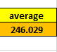

**Q5. Which months experienced the highest and lowest call volumes?**

Ans. There are only 34 days are given which is of only two months December and January. 31 days of December and only 3 days of January.

Highest – December

Lowest – January

**APPROACH:** On 10/12/23 there was highest call volume i.e **430**

Formula used- =Max(call volume column)

On 03/01/2024 there was lowest call volume i.e. **107.**

Formula used **-** =Min(call volume column)

**Q6.What is total operational cost for that month?**

Ans.

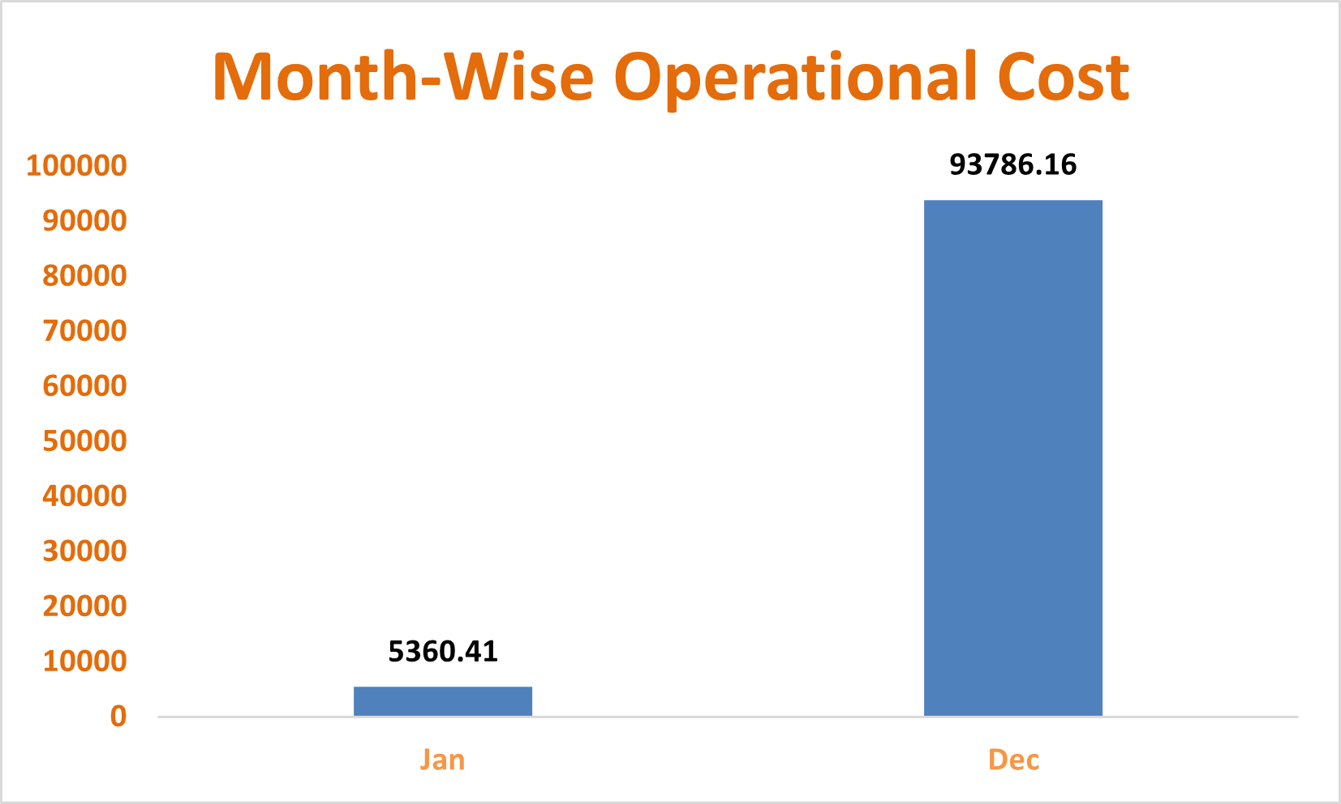 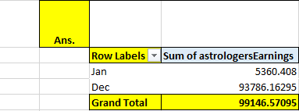

**Q7.What is the average number of calls handled per agent per day?**

Ans. 2 (Rounding off)

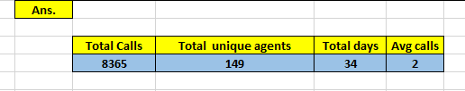

**Approach:**Using this formula, =((K29/L29)/M29) we can obtain the average number of calls handled per agent per day.Average number of calls handled by per agent per day = Average number of calls per day / Number of Agent

**Q8.How many repeat callers are there, and what percentage of total calls do they represent?**

Ans. APPROACH:

I Created Pivot Table: Rows = uid, Values = Count of CallSid

Applied Value Filter: Count of CallSid > 1

Then manually selected unique uid values

Excel status bar showed me the Count = 1275

So, Final Answer: 1275 repeat users

Subtracted 1 from each user’s call count (to exclude their first call)

Total repeat calls after subtraction = **4737**

Repeat Call % = (4737 / 8365) * 100 = 57.% ( Roundoff)

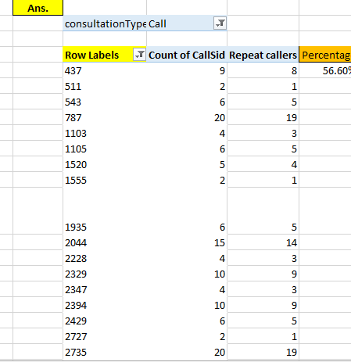

**Q9.What are the total sales generated by the call centre for each product category?**

**Approach**: Using the pivot table, we have obtained the following table

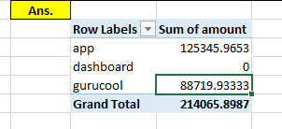

### **Observation:**

* **App**: ₹125,435.95 Highest sales contributor.
* **Gurucool**: ₹88,719.93 Performing well, close to the App.
* **Dashboard**: ₹0 No sales

### **Key Insight:**

* Sales are largely driven by the **App** and **Gurucool**.
* **Dashboard** requires further investigation either underperforming or inactive.

.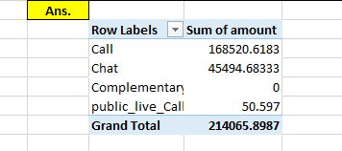

**Q10.How many calls were made for each user ID and guru ID?**

Ans. 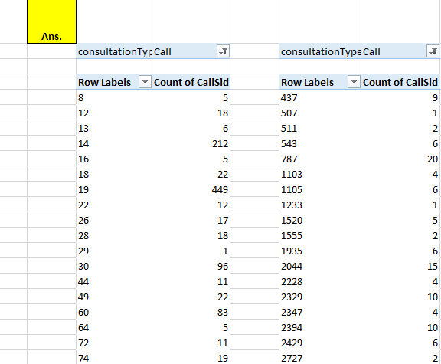

APPROACH : To answer this, I created **two separate Pivot Tables**, one for uid and one for gid, to showcase the total number of calls associated with each user and each guru.

*Calls by User ID (uid):*

I chose the entire dataset and created a Pivot Table.

Then I moved uid to the Rows section and CallSid to the Values section.

I ensured that the aggregate was set to Count of CallSid.

This table clearly indicates how many calls each user made to the call center. It aids in determining user engagement levels.

*Calls by Guru ID (gid):*

I used the same dataset to generate another Pivot Table.

This time, I added gid to the Rows section and used CallSid in the Values section with the Count option.

This enabled me examine the number of calls addressed by each guru, providing insights on individual performance or load distribution.

**Q11.What is the correlation between call duration and customer satisfaction?**

Ans. The correlation between call duration and customer satisfaction is 0.000202451

**Approach:** Using the CORREL function using the Call duration and rating fields resxpectively.

**Insights:** A correlation of (-0.00025) indicates an extremely weak negative relationship between call duration and rating. However, the value is so close to 0 that it essentially suggests no meaningful linear relationship between the two variables.

Formula Used: =CORREL(AN7:AN3456,AP7:AP3456)

=CORREL(AO7:AO3456,AP7:AP3456)

**Q12.Which guru has the highest and lowest customer satisfaction scores?**

Ans. **Approach**: Using the following pivot table , We obtained the highest and lowest satisfaction scores with the aggregate function i.e. MIN AND MAX

Lowest Customer Satisfaction: =MIN(AQ15:AQ163)

Highest Customer Satisfaction= =Max(AQ15:AQ163)

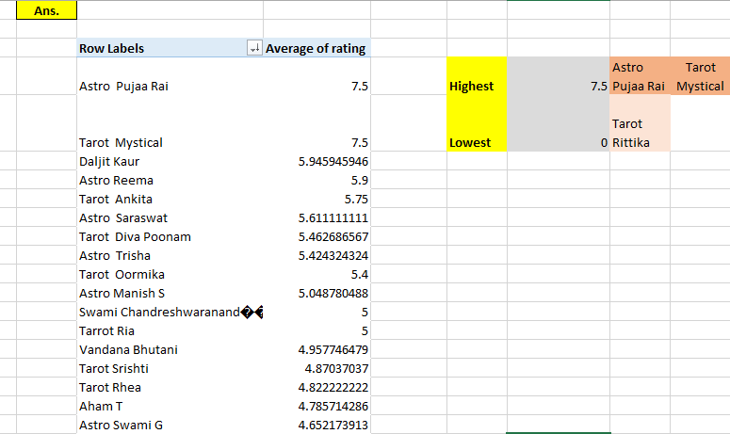

**Q13.What is average customer satisfaction score by month?**

Ans. **Approach:** Using the following pivot table, we have obtained the average customer satisfaction score by month.

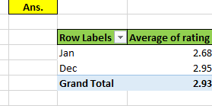

**Insights:** There are only two months are given in data i.e. December 2023 and January 2024.

**December – 2.95 January – 2.68**

**Q14.How many categorical columns are there in the data?**

Ans. There are 15 categorical columns in the data.

**Insights:**

**Definition:** These are variables that represent distinct categories or groups. The values are typically qualitative and can be divided into discrete, non-numeric groups or labels.

**Categorical columns are:(From raw dataset)**

_id CallSid

user, astrologerCallStatus

chatStatus region

guru userCallStatus

guruName gid

uid callStatus

consultationType callIvrType

website FreeChat

RefundStatus callChannel

isWhiteListUser FreeCall

queue

**They are categorical columns because the show characteristics like –**

**Qualitative:** They represent descriptive characteristics or labels.

**Discrete:** There is a limited or fixed number of values.

**Non-numeric:** Though some categorical variables can be numeric (like ID numbers), the numbers don't have mathematical meaning.

**2) Continuous Columns:**

**Definition:** These are variables that can take on any value within a certain range and are typically numeric. They represent measurable quantities.

**Continuous Columns are : (From raw data)**

chatSeconds timeDuration

amount astrologerOnCallDuration

astrologersEarnings netAmoun

userOnCallDuration rating

**They are Continuous columns because the show characteristics like –**

**Quantitative:** The data can be measured and expressed numerically.

**Continuous:** They can take any value within a range, including decimals.

**Mathematically meaningful:** You can apply arithmetic operations like addition and subtraction to continuous data.

**Subjective Question:**

**Q1.Should the investment be used to hire more agents, improve training programs, or upgrade call center technology?**

Hiring More Agents

**Insights:**As per the dataset presented Astrosage is an astrology based consultation call center. Therefore all the above mentioned points are equally important for the growth of organization but the most sustinable and significant option is going to be upgrading call center technology.

C:\Users\Lenovo\Desktop\ss5.PNG

**APPROACH** :The above table shows that the count of astrologers as per the total calls. Here for astrologer count we have used the COUNTA function along with the unique function. And total calls to get a ratio of calls per astrologer.

**Recommendations:**As per the above data it is quite visible that hiring is not a very necessary need for the call center.

IMPROVE TRAINING PROGRAMS

**Insights**: In the following, Area chart shows the average rating of different Astrologers as per the given dataset which provides an important insight that the ratings vary with a very variable disturbance which implies a need of effective training to improve the quality of consultation resulting in improved ratings.

**Recommendation:**

Yes, a good amount of money should be spent on Improving Training Programs.

UPGRADE CALL CENTRE TECHNOLOGY

Approach Create a chart for a detailed view of Call- status Distribution.

**Insights**: In the above , Pie chart shows the call status distribution as per the chart there is a need for the technological update to increase the completed calls rate. Hence there is a need for a Technological update to increase the customer satisfaction. In above Charts we can see that 27% of Chats have failed due to technical issue. Since already customer are not satisfied from agent services if calls and chats will fail then it will directly impact the ratings and customer retention rate.

**Recommendation:**

The call centre should not Hire more agents as of now instead they should focus on Increasing their Satisfaction Rates.

**Q2.What are the potential risks of each investment option (hiring, training, technology upgrades), and how can they be mitigated?**

**Hiring More Agents:**

**Risks:**

* Overstaffing: Hiring too many agents can lead to increased payroll costs without a proportional rise in call volume.
* Hiring mismatches: New hires may lack communication skills or alignment with company values.
* High turnover: Call centre jobs often have high attrition rates, wasting recruitment costs.

**Mitigation:**

* Use **historical call data** and forecasts to determine optimal staffing levels.
* Implement a **structured recruitment process** with assessments for soft skills and astrology-related knowledge (for AstroSage).
* Offer competitive benefits and growth paths to improve **employee retention**.
* Use **contract or part-time hires** during seasonal spikes before committing full-time.

**Training Programs**

**Risks:**

* **Ineffective training content:** Poor-quality training may not improve agent performance.
* **Time away from calls:** Training takes agents off the floor, possibly affecting customer service levels.
* **One-size-fits-all approach:** Uniform training may not address individual skill gaps.

**Mitigation:**

* Use **performance analytics** to identify specific training needs (e.g., based on rating, call duration).
* Use **blended learning models** — mix short, flexible online modules with live coaching.
* Schedule training during **low call volume hours**.
* Track post-training performance metrics to evaluate ROI.

**Technology Upgrades (CRM, IVR, AI chatbots, etc.)**

**Risks:**

* **High upfront cost**: Can strain budget if not properly scoped.
* **Employee resistance**: Agents may struggle with new tools or resist change.
* **Integration issues**: New systems may not work well with existing software.
* **Downtime during transition**: May affect customer service.

**Mitigation:**

* Start with **pilot programs** to test tools before full deployment.
* Choose **scalable and modular** systems with strong vendor support.
* Provide **hands-on training** and involve agents in feedback loops.
* Plan upgrades during **non-peak hours** and have backup support ready.

**Q3.How does AstroSage's call center performance compare to AstroGuru's average call volume, customer satisfaction, and agent performance?**

**Will you use any aggregation function or a visualization here to solve the problem?**

Ans.

**Approach**:For comparison of AstroSage and AstroGuru we don’t have any dataset of AstroGuru . Hypothetically if it was available we can easily perform the analysis by

1. Using pivot tables, we can find the total calls and average calls and compare.
2. We can make a pivot chart for user wise rating and astrologer wise rating compare it for both the call centres.
3. For agent performance we can make a bar chart of calls handled vs Astrologer Name.

Also, can make a Pivot Chart for Top performers of Both the call centres and compare them.

**Q4.How can the call centre improve its handling of peak call periods to ensure high customer satisfaction?**

**Mention the functionality you will use for giving the suggestions, will it be any aggregated function or a visualization?**

**APPROACH** :As visible from the above chart we have a very variable flow of peak hours so the company can communicate with consultants and make an effective workflow by monitoring the availability of them and make batches, for different hours of the day and allow the customer to choose among the available one's. Moreover, restrict each consultant on defined number of sessions only.

Here we can clearly see from the graph where vertical axis represents the peak hours and horizontal axis represents the total calls.

**Insights:**

**Peak Call Hours**: Between **6 AM to 4 PM**, with a **spike at 07–08 AM**

We Can see that the Peak Call hours are from 5 am to 5 pm. During this Periods the work load of agents can be increased drastically which affects the average of ratings during those periods as we can see in above chart, that some hours have fewer average ratings which should not occur for customer retention rate.

**Recommendations: Add more agents** during 6 AM to 4 PM when call traffic is consistently high

Analyse **agent-level ratings** during hours like **3 PM** where ratings dip

Conduct quick coaching or performance review for specific time slots

Review if technical issues or rushed handling occurs in those hours

Schedule more experienced agents during volatile satisfaction hours (like 3 PM & 6 PM)

**call-back feature** during long wait times

Inform users of estimated wait time and offer to connect later

Run mock calls during simulated peak loads

**Q5.Based on historical data, what strategic initiatives should be prioritized to improve efficiency and customer satisfaction?**

**Ans;**

**Approach:** Create a chart for Call status Distribution and Rating Wise Distribution and got the following insights

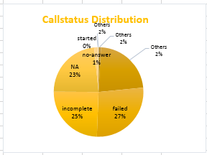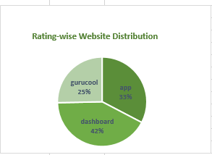

**Insights:** Based on the above visualisation i.e.

1. Call status Distribution
2. Consultation Wise Ratings
3. Peak hours as per calls received

The call centre can adopt following strategies

**Optimizing operational Efficiency** -: The call centre can focus on allocating uniform number of calls to all the astrologers on a daily basis. They can do batching of a particular number of consultants and let the customer choose the consultant through a pre booking and remove them as soon as they get selected for a threshold value (Like 10 calls a day). As per the availability of consultants.

**Improving Customer satisfaction -:**

1. Technological update is a must to increase the quality of consultation so that the call completion ratio could be increased at least up to 60% which is currently at 23%. For a good customer review properly consulting and completing the call is very important. The call centre can optimize the Dashboard as well as the App for better user experience more customer retention. Moreover, it’s important to have a backup consultant in case the assigned consultant cannot continue with call. Also, the organization should provide a free/discounted session if it gets cancelled or the consultant is not available.
2. They should focus on streamlining the chat process through chatbots for general queries based on the past records also AI can be used as well for better and fast customer service.
3. CRM software must be used to assign a consultant to customer for all the queries giving a familiar experience just as happens with a patient having a constant Family doctor. This will help as the Consultant would be having all details of customer from mentality to Behaviour. This will result in complete resolution of queries from customer.

**Recommendations**: 1 Dynamic Workforce Planning

**Why:**

* Call volume peaks from **6 AM to 4 PM**, especially **7–9 AM**
* Ratings dip during some peak hours — suggests agent overload

**Benefits:**

* Reduced customer wait time
* Less agent fatigue → better handling → improved satisfaction

2 **Improve Call Routing & IVR Optimization**

**Why:**

* If call duration is long or agent performance varies, inefficient routing may exist
* Long holds or wrong agent match impact satisfaction

**Benefits:**

* Faster resolution
* Less dependency on human agents
* Higher customer satisfaction

3 **Targeted Agent Training & Performance Coaching**

**Why:**

* Ratings vary by time → likely due to inconsistent handling
* Some agents may need support under high pressure

**Benefits:**

* More consistent service quality
* Improved agent morale and retention

4 **Expand Support Coverage During Missed Opportunity Hours**

**Why:**

* Early morning and late evening still get decent call volumes (but lower satisfaction)
* Limited staffing may be hurting experience

**Action:**

* Add **part-time or flexible agents** during these fringe hours
* Consider remote workforce to extend time coverage

**Benefits:**

* Capture missed revenue
* Serve different time zones better
* Improve satisfaction in off-peak periods

5 **Post-Call Feedback Loop + Automated Follow-ups**

**Why:**

* Satisfaction drops may go unnoticed without timely feedback
* Silent dissatisfaction can hurt reputation

**Action:**

* Trigger post-call surveys (1–5 rating or emoji-based)
* Use responses to auto-trigger escalation or apology workflows

**Benefits:**

* Real-time feedback = quicker resolution
* Shows care, which boosts long-term loyalty

**Q6.What can be the key factors contributing to high customer satisfaction scores, and how can these be leveraged to improve overall performance?**

**What is the basis for the suggestions? And mention how you decided if the satisfaction score affects the ratings.**

Ans**. Approach:** Create a pivot chart and we took ratings as customer satisfaction criteria since no other attribute is present]

|  |  |
| --- | --- |
| **Row Labels** | **Average of rating** |
| Call | 3.5 |
| Chat | 2.7 |
| Complementary | 4.5 |
| public_live_Call | 3.0 |
| **Grand Total** | **2.9** |

|  |  |
| --- | --- |
| consultationType | (All) |
|  |  |
| **Row Labels** | **Average of astrologerOnCallDuration** |
| 0 | 0.0 |
| 1 | 0.0 |
| 2 | 64.1 |
| 3 | 58.6 |
| 4 | 124.3 |
| 5 | 127.4 |
| 6 | 0.0 |
| 7 | 0.0 |
| 8 | 0.0 |

|  |  |
| --- | --- |
| **Row Labels** | **Average of userOnCallDuration** |
| 0 | 0.0 |
| 1 | 0.0 |
| 2 | 59.2 |
| 3 | 53.8 |
| 4 | 114.9 |
| 5 | 117.7 |
| 6 | 0.0 |
| 7 | 0.0 |
| 8 | 0.0 |

The consultation type, Astrologer on call duration are the key factors for customer satisfaction. As we can see from above pivot tables the chat customers are more satisfied, whereas call customers with a higher call duration have provided higher rating.

**Recommendations**: So the call centre should focus on complete customer query resolution, if general then through chat otherwise a detailed call session it could result even better it is a video session that could be pre booked.

**Q7.How should the call centre balance the workload among agents to ensure optimal performance and avoid burnout?**

**Mention your approach and spreadsheet function for the answer.**

APPROACH -

1. Creating a pivot table with astrologer name in rows and call volume and respective average rating in values.
2. This help us to analyse how each guru is efficient and which guru is overburdened and which is less

Observation and analysis –

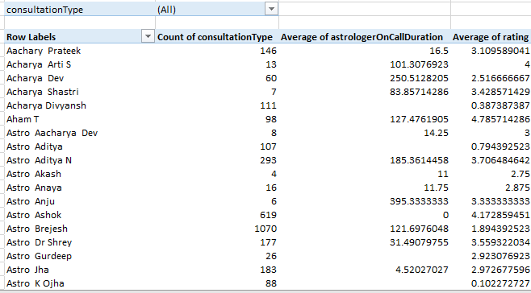

**Insights:**

* According to the above charts, which compare Average Call/Chat time and Count of Calls/Chats for each guru, we observe that: -
* The line graph of Count of Calls in mostly under the line graph of Average Call Seconds with some spikes in Call Seconds line graph, possibly causing burn out for those gurus.
* In Chats, none of the gurus have 0 chat time and initially chat time is more, chats are less but as we move towards later area of graph, count of chats becoming more and more and chat time is pretty much same, causing possible burnouts.
* In the Calls chart, G_id 29 has longest Call of 1620 sec but this agent has only done 1 call over the period. On the contrary, G_id 256 has made 1060 calls but average call time is 387 sec. So, division of workload is not up to the mark causing low ratings.
* Similarly in Chats graph, we can see that G_ids 29 and 80 has longer chat times but their count of chats is low. On the contrary, G_ids 239, 281 and 287 have more chat counts than any other agent but their chat times are less.
* The above two figures of Chats and Calls graph, shows that agents having more chat/call counts with less chat/call time might be able to resolve issues as fast than any other agents.
* There are many ways: -
* Using Predictive analytics for forecasting high-volume periods, so that Agent allocation management can be improved
* Implementing Rotational Shifts. Avoid consistently assigning the same agents to peak hours.
* Using AI Chatbots to handle FAQs and reduce the number of calls reaching agents.
* Hiring part-time agents which can reduce load on High-rated agents. But training them is crucial to sustain in the market.
* Schedule regular breaks to prevent fatigue and burnout during long shifts.

**Recommendations**

1. Identify Top & Bottom Performers → Reward or retrain accordingly.
2. Balance Call Distribution → Prevent overloading popular Gurus.
3. Implement Time Management → Reduce unnecessarily long calls.
4. Introduce Automation → Handle simple queries via chatbots.
5. Monitor & Adjust → Track changes in ratings and call volumes post-optimization.

**Q8** What new technologies or tools could be implemented to enhance call center operations and customer service?

**Answer** - We can enhance call center operations and customer service through:

* AI Chatbots: Streamline initial interactions by identifying customer issues, saving agents time.
* Predictive Analysis: Forecast demand to optimize resource allocation, reduce agent pressure, and improve ratings.
* Speech Analytics: Monitor communication quality, identify areas for improvement, and refine training programs.
* CRM System: Enhance personalization and meet the needs of repeat callers effectively.

The call centre must try and use all the consultants equally to manage the workload by assigning them equal number of calls by assigning calls to them as per the availability, moreover they can also focus on pre-booking model and use effective UI to give users an option to select the consultants to provide better user experience, equalising workload by removing the consultant as soon as they are chosen for a threshold count of bookings.

As shown in the below chart there is an uneven distribution of calls among the consultants.

The Top 10 consultants cover 44% of total calls.

**Q8.What new technologies or tools could be implemented to enhance call center operations and customer service?**

* Introduction to chatbots and Virtual assistants for regular queries can help in saving the consultants energy for complex queries and consultations.
* Use of AI for personalization based on some insights of customer for better user experience can result in repeat orders/consultations.
* Maintaining a CRM software about past consultations and customer details can help in future consultations and targeting old customers.
* Feedback mechanism should be adopted to make the customers happy and improve the quality.
* Personalized pre booked video sessions with consultants can help in the repeat customers as the interaction helps in understanding the customer behaviour.
* Developing apps with different notifications and games such as puzzles and making the customers learn about the birth charts and planets can attract new customers.

**Q9.What metrics should be included in the final dashboard to comprehensively view call center performance and guide investment decisions?**

**DASHBOARD VISUALIZATION**

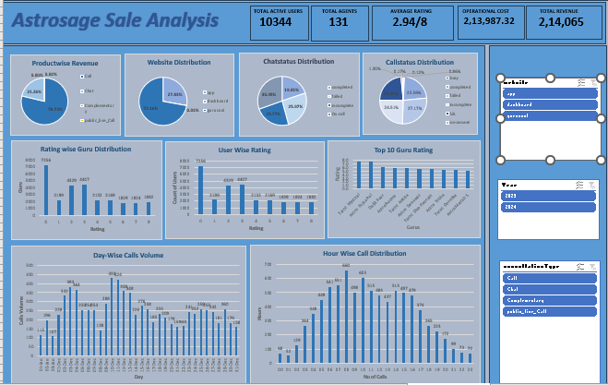

1. website distribution

2. Revenue generated by category type

3. Call distribution over hrs

4. Day by day call volume

5. Call status distribution

6. Chat status distribution

7. Rating wise guru distribution

8. Rating wise customer distribution

9. Top 10 guru by Rating

**Q10.How would you allocate a 1 crore rupee investment to optimize operational efficiency, enhance customer satisfaction, and boost profitability, and what analysis-based recommendations would you offer to support this?**

**[you have to give bullet pointers to answer this question]**

Ans. 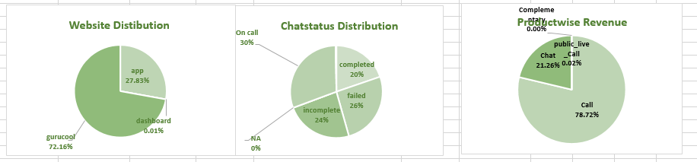

* Astro-sage should focus upon Technological upgrades to bring customers to the app and dashboard more frequently and decrease the cancelled and failed consultations to improve the profitability.
* Astro-sage should focus on call consultations to increase the revenue and installs some chatbots and virtual assistant for general chat process instead of consultants to have them available for the peak hours to reduce the operational cost.
* Astro sage should focus upon the pre-booking model and include CRM Software to assign a particular client to a particular customer to increase customer satisfaction and reduce time lapse and repetitive procedure of intro sessions.
* Finally, Astro- sage must allow a customer to choose a consultant and take feedbacks of the session. And weekly distribute the most rated and most appreciated astrologer’s session recording to others and organize regular training to stay up to date and keep all the consultants on the same level , to maintain the quality and consistency of the session.

